Short Answers:

1. When performing interest point detection with the Laplacian of Gaussian, how would

results differ if we were to (a) take any positions that are local maxima in scale-space, or (b)

take any positions whose filter response exceeds a threshold? Specifically, what is the impact

on repeatability or distinctiveness of the resulting interest points?

Solution 1:

The scale of the of the interest points is determined by the Scale Space. The scale of the interest point may have different values for the different local maxima’s. Therefore,we will have less distinctive but more repeatable features.

Furthermore, the thresholding pipeline depends on the threshold value. If the threshold value is too high, local maxima may not pass and the result will be an empty set for the interest point. For that reason, using thresholding will be more distinctive (since all the candidates on different frames will be similar.) but less repetitive.

2. What exactly does the value recorded in a single dimension of a SIFT keypoint descriptor

Signify?

Solution2:

This value in the single valued SIFT keypoint descriptor signifies the all the independently interest points . It represents all the gradient direction for a single patch . For the assignment we do we took a SIFT points of 128 dimension. Where every patch is considered as 4*4 pixels length and each pixel stores the 8 gradient direction. And sift features represent the descriptor points . They use the histograms to bin pixels within the subpatches with a varied orientations. They are unique for all the lighting conditions , Rotation because the rotate patch is according to its dominant gradient.

Programming Code Questions:

1.Raw descriptor matching [20 pts]: Allow a user to select a region of interest (see

provided selectRegion.m) in one frame, and then match descriptors in that region to

descriptors in the second image based on Euclidean distance in SIFT space. Display the selected region of interest in the first image (a polygon), and the matched features in the second image, something like the below example. Use the two images and associated features in the provided file twoFrameData.mat (in the zip file) to demonstrate. Note, no visual vocabulary should be used for this one. Name your script raw_descriptor_matches.m

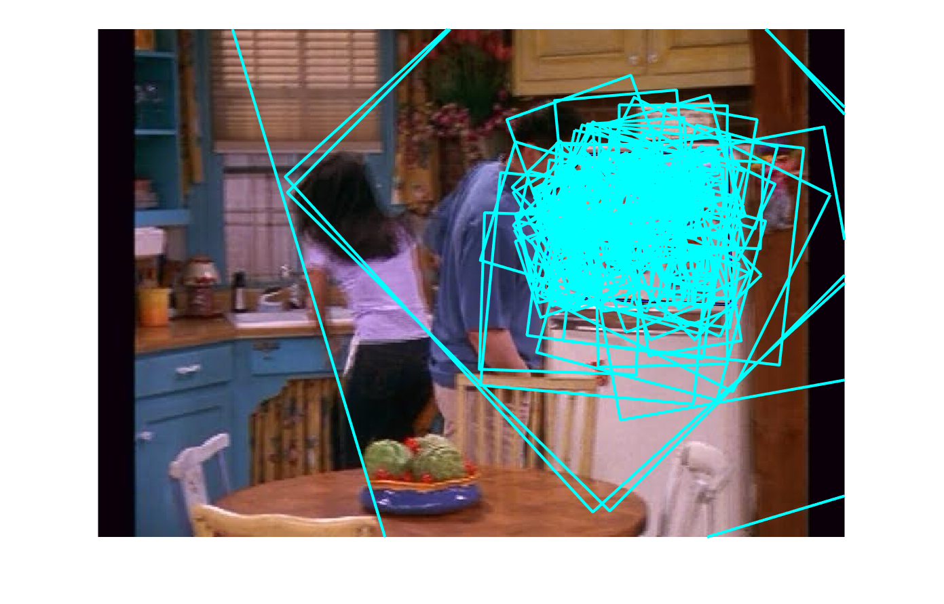

Figure 1: SIFT DESCRIPTORS DISPLAY

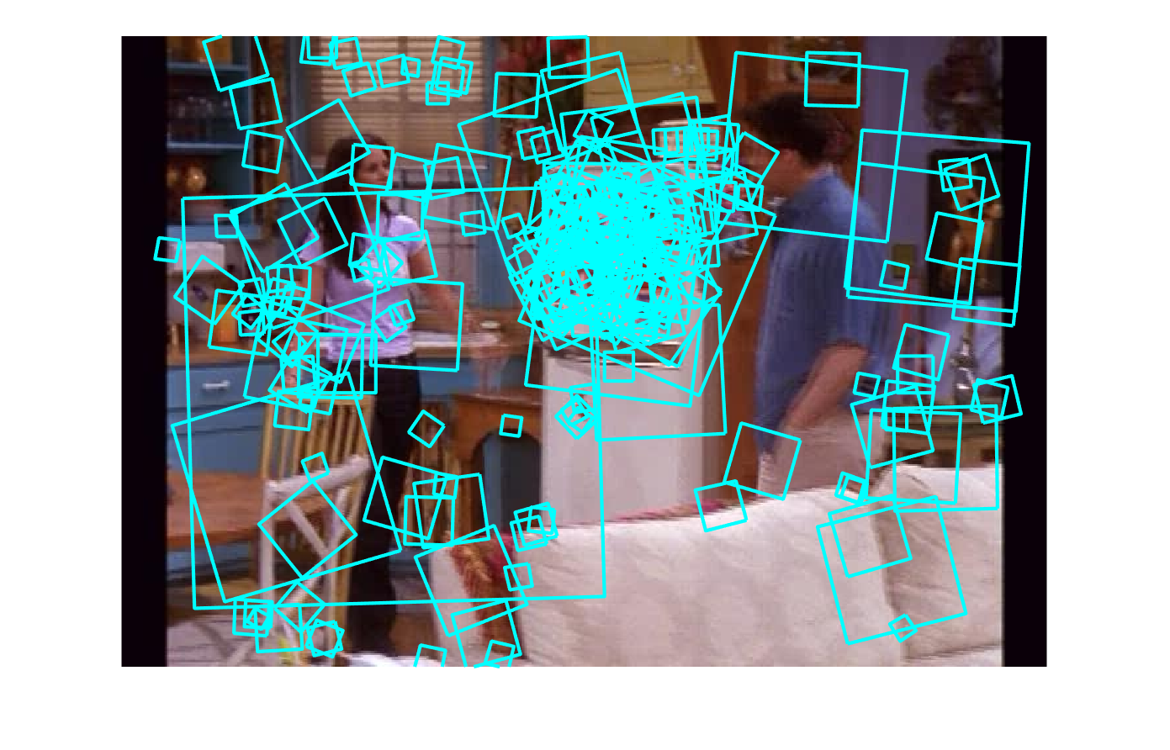

Figure 2: SIFT descriptors in 2nd image corresponding to the SIFT descriptor in the first image

All the SIFT descriptors detected in the above Figure 1 are detected for a part of refrigerator's door where as the SIFT descriptors detected for the image 2 is based on the descriptors having the least euclidean distance with the image 1 detected SIFT features.

2.

Visualizing the vocabulary [20 pts]: Build a visual vocabulary. Display example image patches

associated with two of the visual words. Choose two words that are distinct to illustrate what

the different words are capturing, and display enough patch examples so the word content is

evident (e.g., say 25 patches per word displayed). See provided helper function

getPatchFromSIFTParameters.m. Explain what you see. Name your script

visualize_vocabulary.m. Please submit your visual words in a file called kMeans.mat.

This file should contain a matrix of size kx128 called kMeans.

Solution 2:

So basically I Stacked all the descriptor values for 300 frames and For k=1500 clusters and Run the K Means on it which group all the similar looking descriptors into different groups in order to create an visual vocabulary.We use this visual vocabulary because it can be very expensive if query image needs to be get compared to many database images. Here I quantize the the visual features into discrete visual words. After I am applying the Kmeans on the all the descriptors. I saved all the centroid values of the kmeans in the kmeans.mat file.

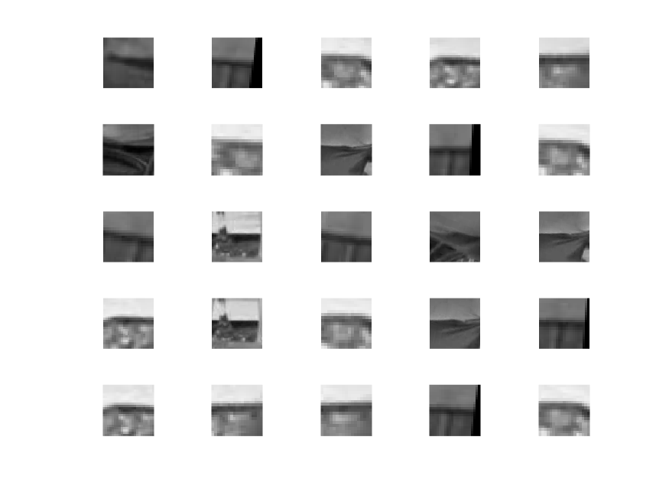 . Figure 3: For Cluster k=1;

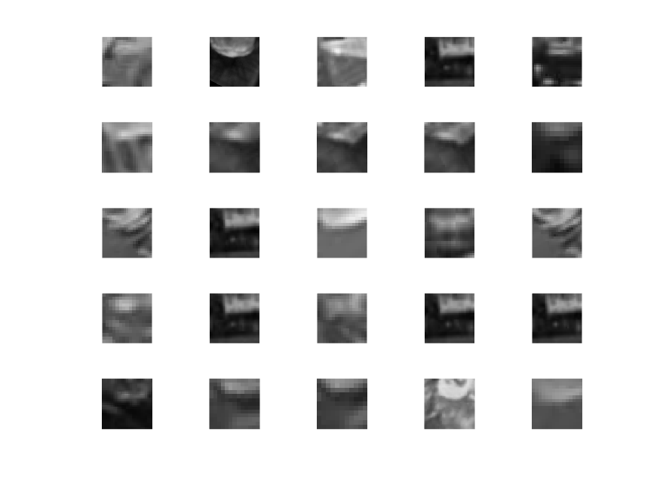

Figure 4 For the Cluster K=2;

3)

Full frame queries [20 pts]: After testing your code for bag-of-words visual search, choose 3

different frames from the entire video dataset to serve as queries. Display each query frame

and its M=5 most similar frames (in rank order) based on the normalized scalar product

between their bag of words histograms. Explain the results. Name your script

full_frame_queries.m

Solution 3.) For this question I created a matrix that stores the histogram values for all the frames across the whole dataset images. And then if you see my third image it is a quite bad result because of the it considering mainly the face descriptors and and not giving importance to the background which is more important for the full frame query to get the images retrieved. This is one important findings I made out of my random three images I selected.

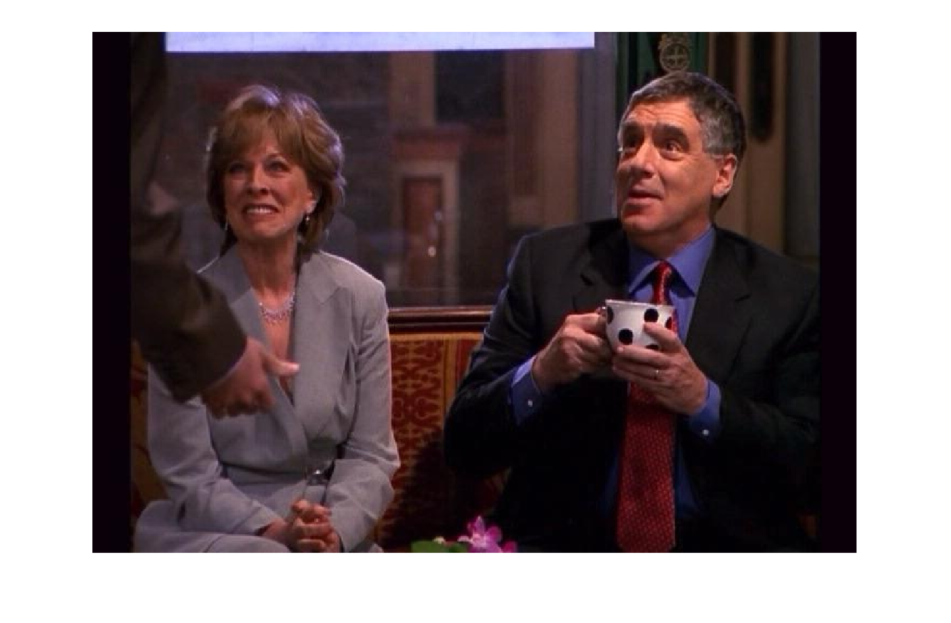

Figure:5

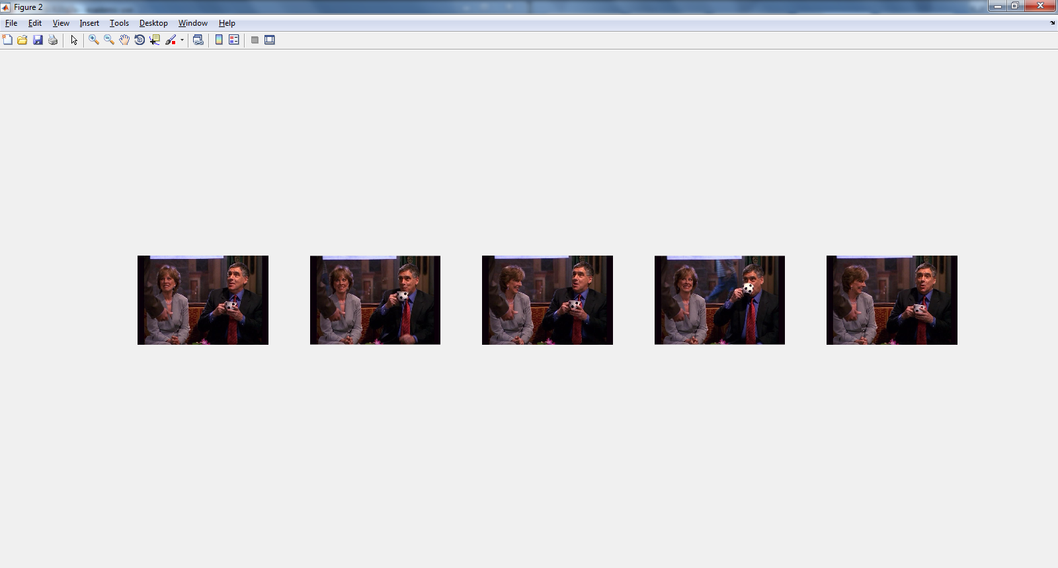

Figure 6

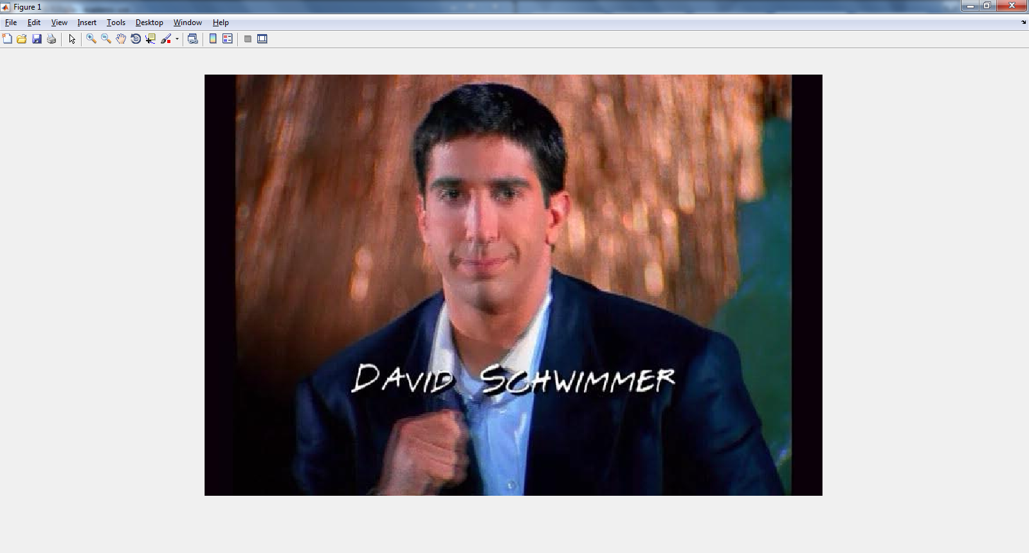

Figure 7

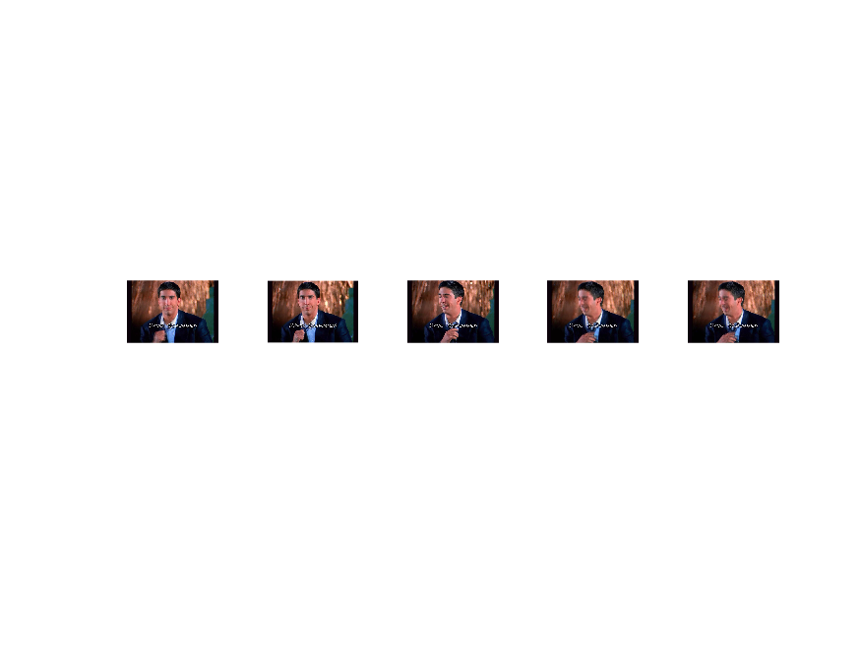

Figure 8: These are top 5 images that are retrieved for the the above given image

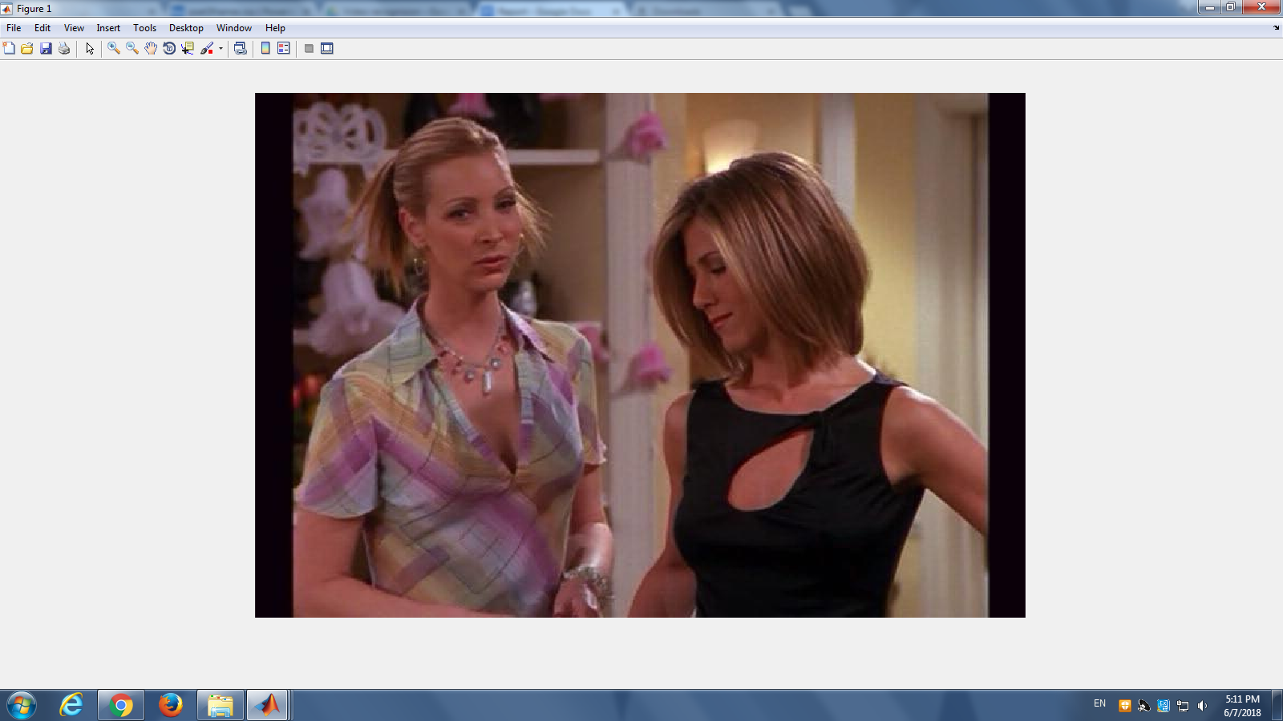

Figure 9

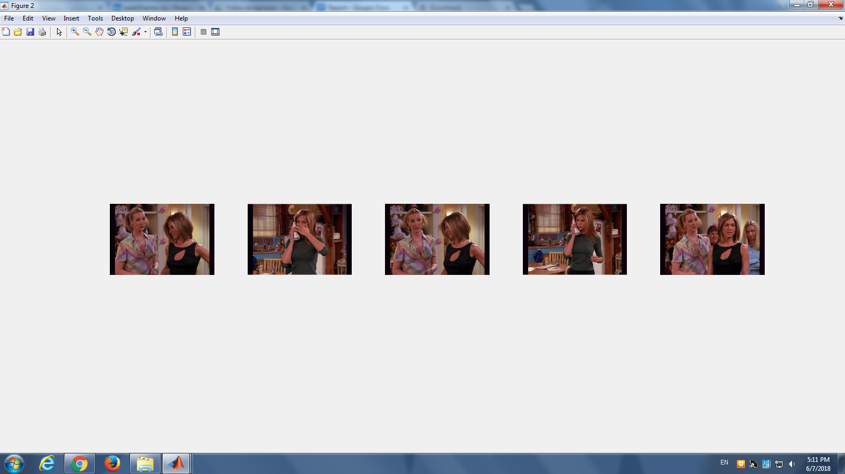

Figure 10: Images that are classifies for the above given image friends_000001060.jpeg

4. Region queries [20 pts]: Select your favorite query regions from within 4 frames (which may be different than those used above) to demonstrate the retrieved frames when only a portion of the SIFT descriptors are used to form a bag of words. Try to include example(s) where the

same object is found in the most similar M frames but amidst different objects or

backgrounds, and also include a failure case. Display each query region (marked in the

frame as a polygon) and its M=5 most similar frames. Explain the results, including possible

reasons for the failure cases. Name your script region_queries.m

Solution 4:

Below is a good example for the most similar image detection.

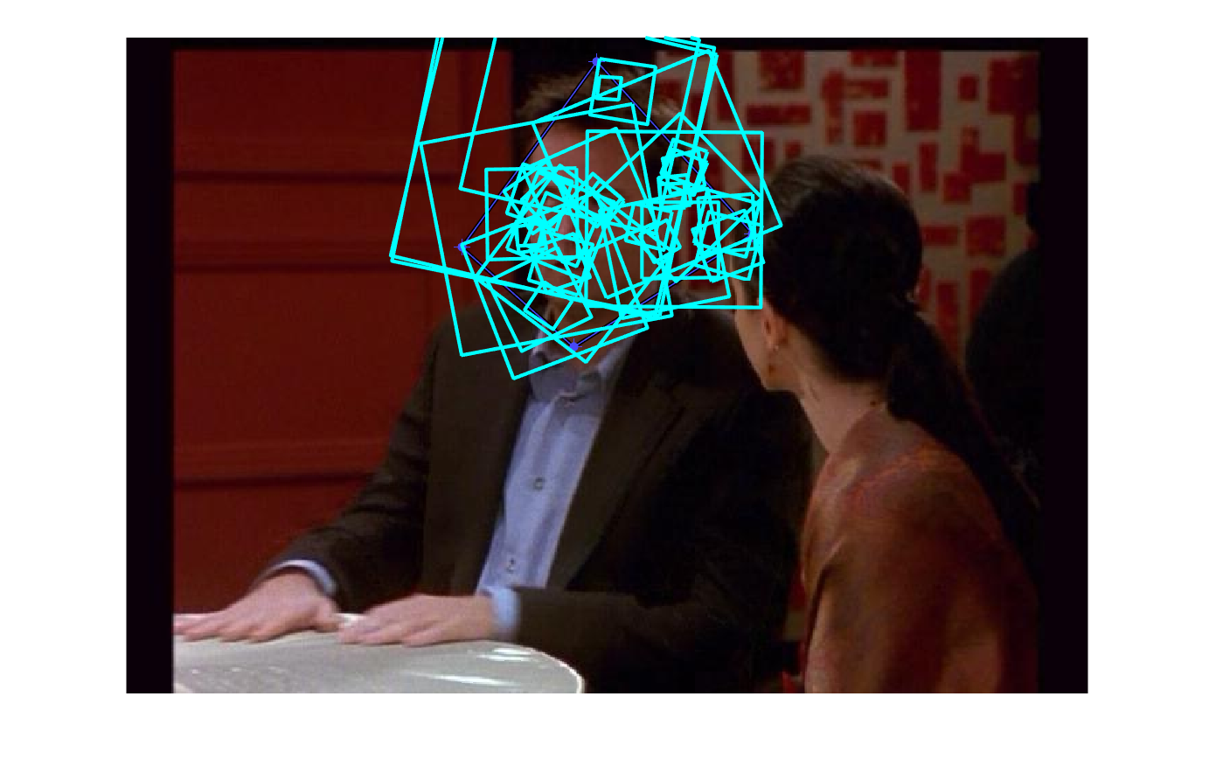

Figure 11: 1st Frame’s selected region SIFT descriptors.

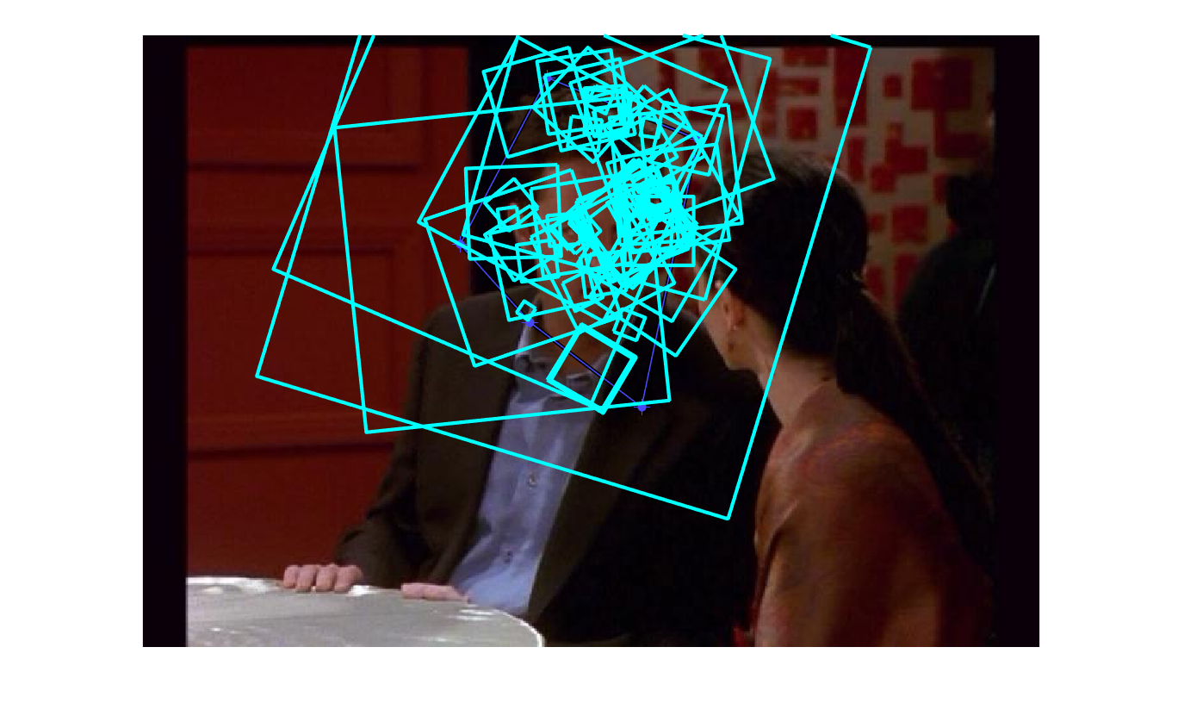

Figure: 12 2nd Frame selected region SIFT descriptors.

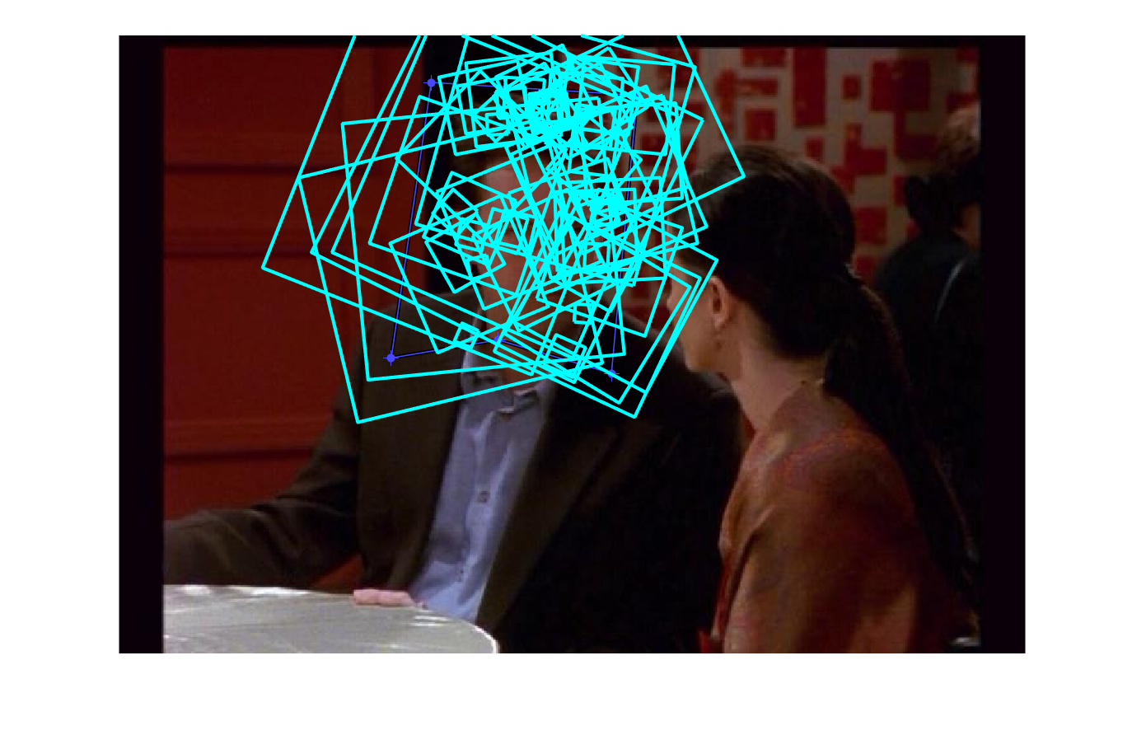

Figure 13: 3rd Frame selected region SIFT descriptors.

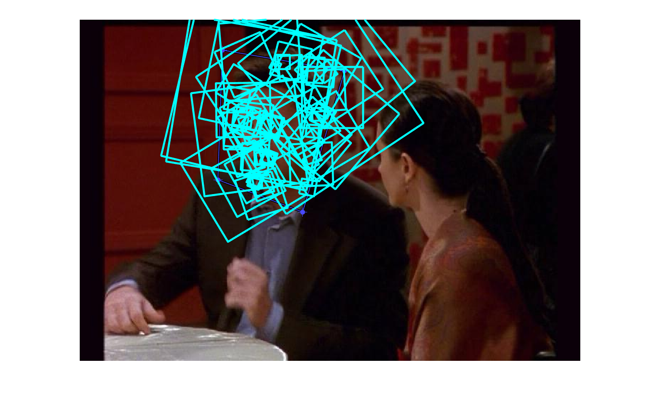

Figure 14: 4th Frame’s selected region SIFT descriptors.

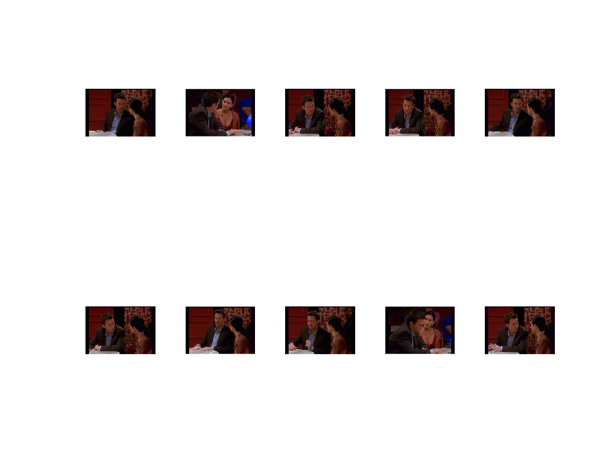

Figure 15: These are the similar output images obtained based on query image

Below is a bad example for the most similar image detection.

Figure 16 shows the selected region for the 1st frame SIFT descriptor for bad example 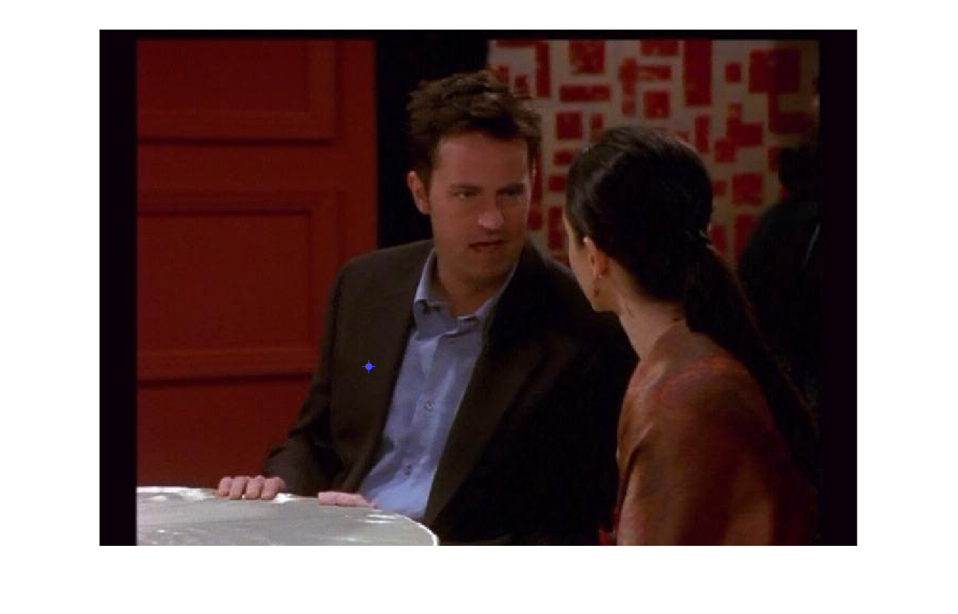

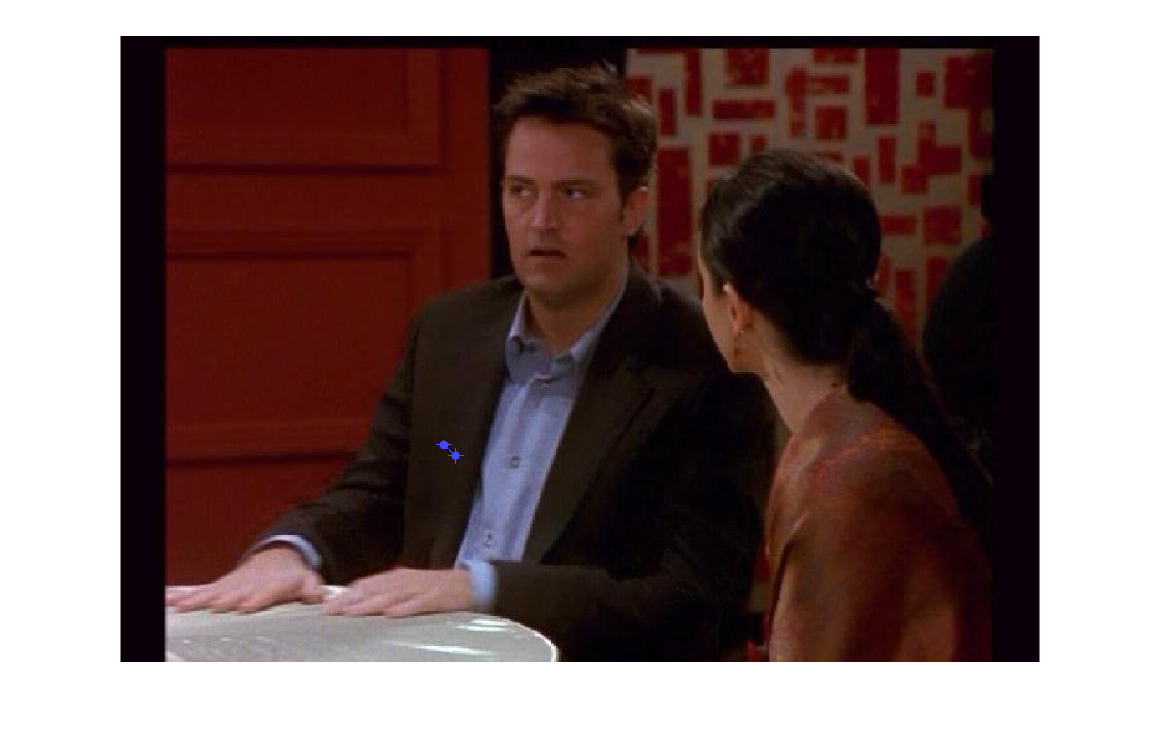

Figure 17:shows the selected region for the 2st frame SIFT descriptor for bad example

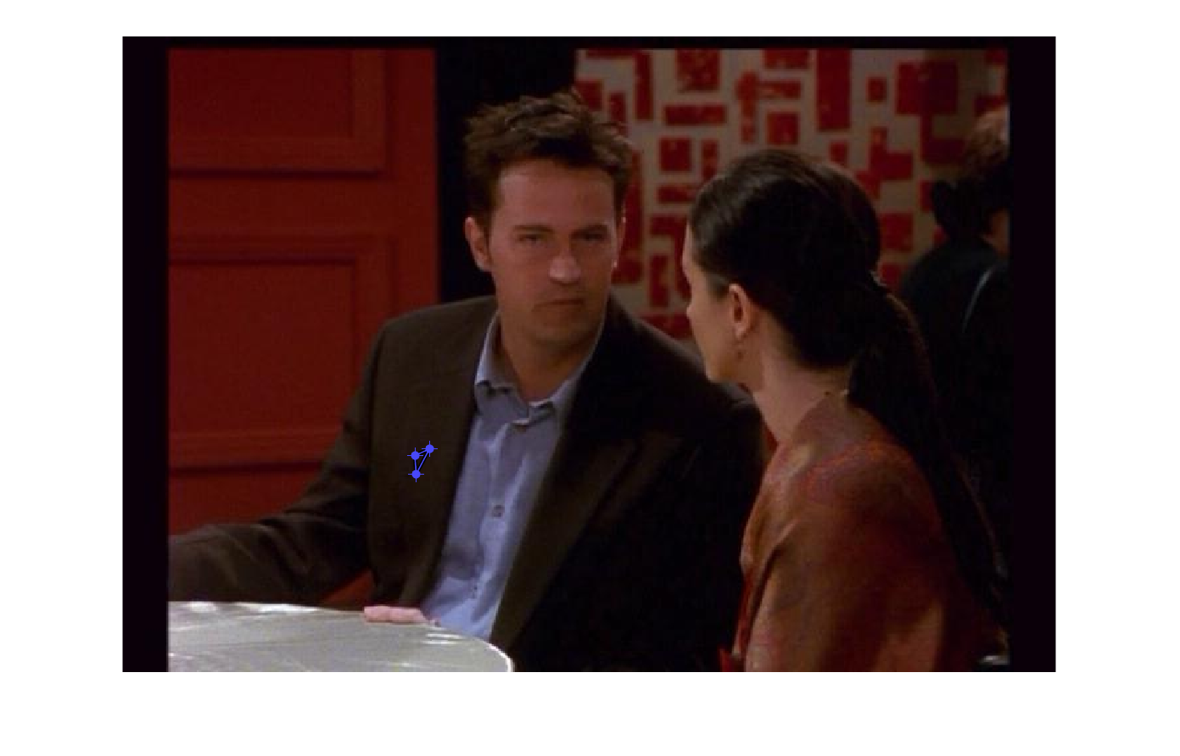

Figure 18: shows the selected region for the 3st frame SIFT descriptor for bad example

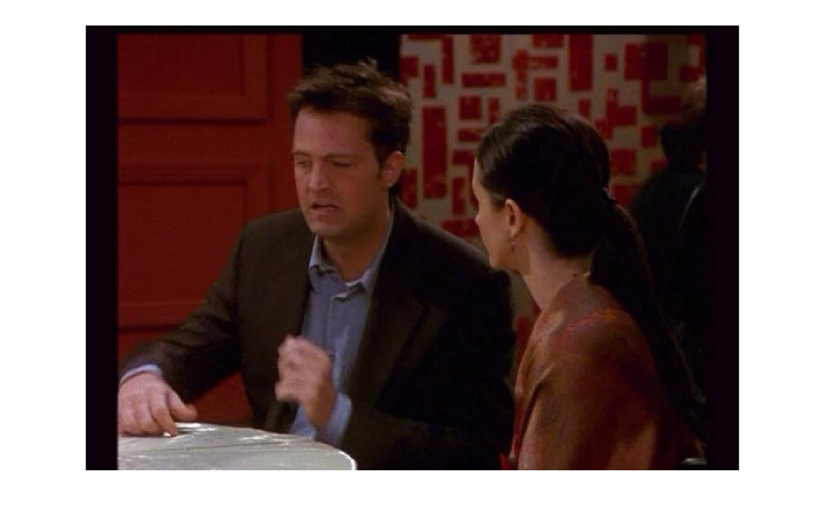

Figure 19: shows the selected region for the 4th frame SIFT descriptor for bad example

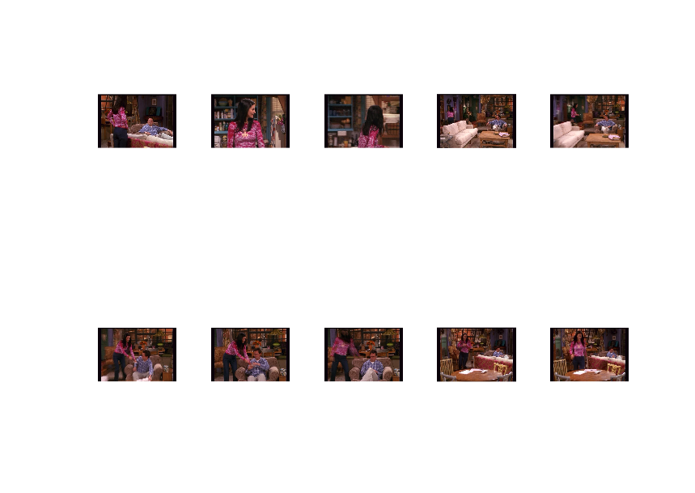

Figure20: These are the similar output images obtained based on query image for bad example

Coding Approach:

So for the above images 4 frames are randomly taken and then I calculated the wordList count based on which cluster the features belong to. For example if the feature belong to cluster k then in that case I will simple increment the count of that particular cluster in the wordList. Similarly I calculated histogram produced per frame and then applied the cosine similarity between the histogram obtained for the all the frames and the wordList which is obtained from the 4 images selected parts. Then sorting all the scores obtained after applying cosine similarity in the descending order and ultimately obtain the similar looking frames with respect to the querying image selected polygon portion.

Good result and Bad result:

So for the good result case Figures 11-15 as I used the man face to be the selected polygon part. So in the similar looking images I can most probably expect to obtain that person face and that is the only results being obtained in the subplot image where the man’s faces comes in all the images.

Where as for the bad classified example Figures 16-20 as we can see on selecting the small selection region in the image under consideration. We found that the similarity image we obtained are different from the query images. This implies that the selection of the descriptor in the query image play a crucial role in searching for the most similar images among the number of frames in consideration.

5.

Full frame queries, Part 2: comparing SIFT bag-of-words with Deep Features[10 pts]:

Use frames friends_0000004503.jpeg and friends_0000000394.jpeg to serve as

queries. For each query display: the query frame and (1) its M=10 most similar frames based on

the normalized scalar product between their bag of words histograms and (2) its M=10 most

similar frames based on the normalized scalar product between their AlexNet fully-connected

layer 7 activation features (stored as variable deepFC7 ). (The AlexNet was pre-trained on the

1000-class ImageNet classification task, and we are using it to extract the layer-7 activation

features for each image.) Explain the differences between the retrieval results obtained using the SIFT bag-of-words features versus the pre-trained deep convolutional neural network features. Which does better? Why? Name your script compare_bow_and_deep.m

Solution 5.)

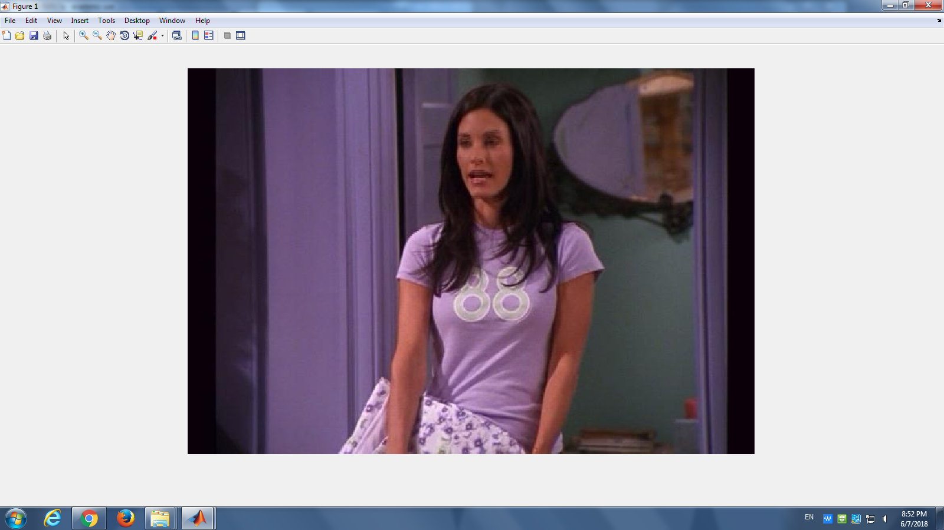

Figure 21: For the frame : friends_0000004503.jpeg

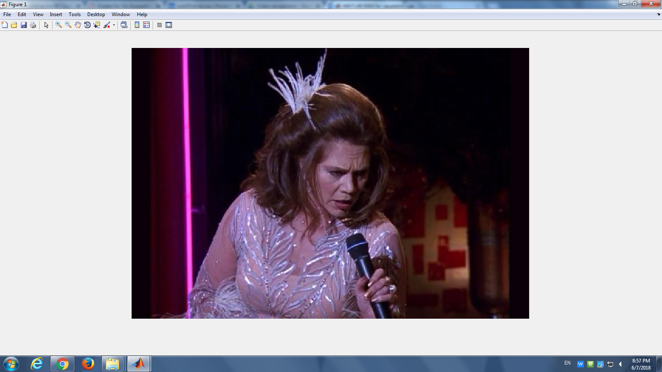

Figure 22: For the frame : friends_000000394.jpeg

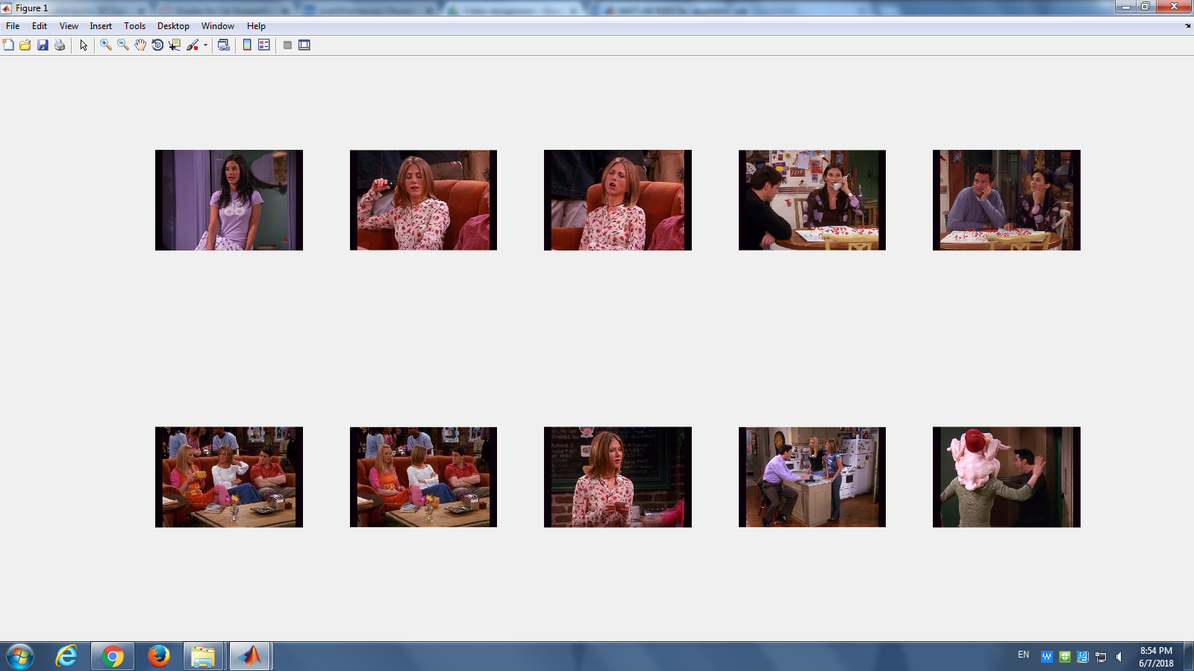

Figure23::This picture is the result of image retrieval of top M=10 for image friends_000004503.jpeg

By normalized scalar product between bag of their histograms.

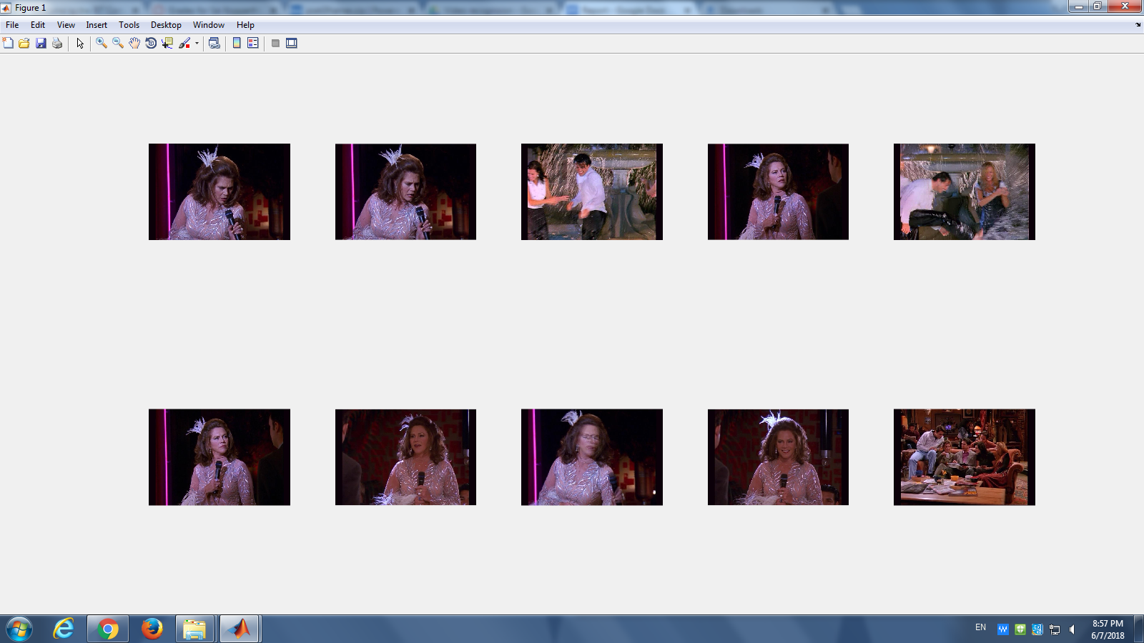

Figure 24::This picture is the result of image retrival of top M=10 for image friends_000000394.jpeg

By normalized scalar product between bag of their histograms.

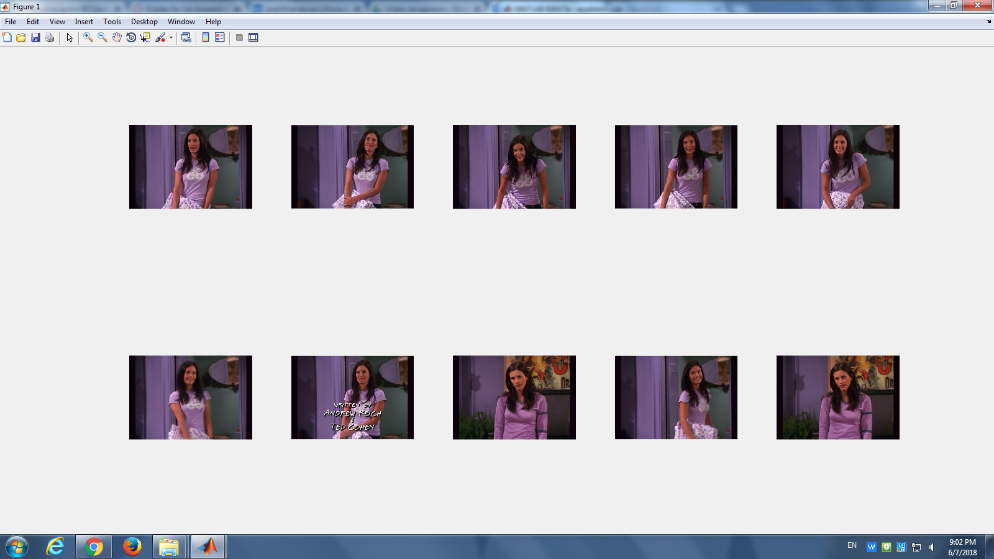

Figure 25:This picture is the result of image retrival of top M=10 for image friends_000000394.jpeg

By normalized scalar product between their AlexNet fully connected layer 7 features.

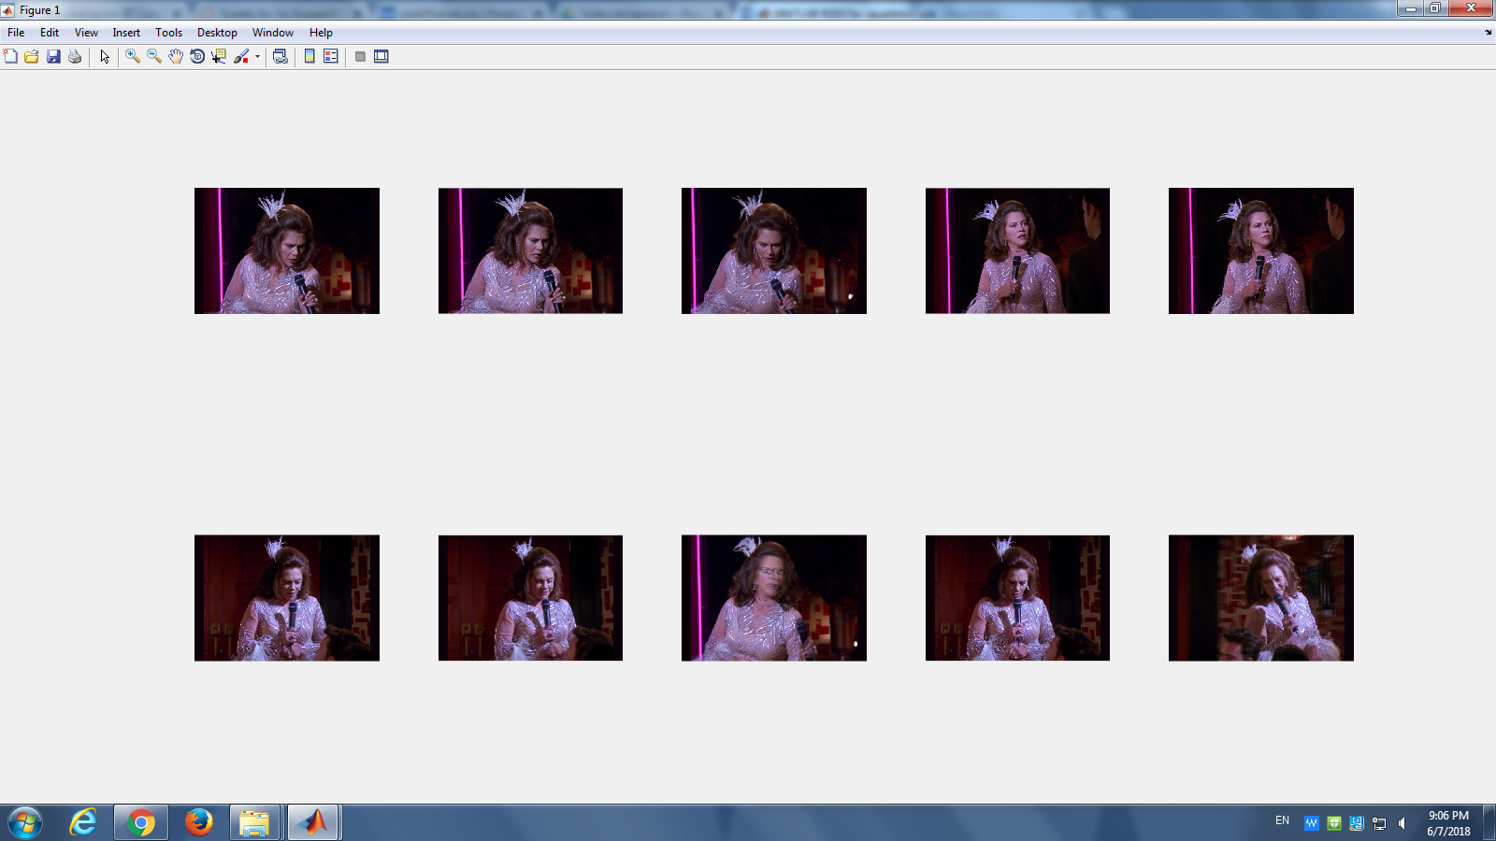

Figure 26:This picture is the result of image retrieval of top M=10 for image friends_000004503.jpeg

By normalized scalar product between their AlexNet fully connected layer 7 features.

So as the AlexNet uses the 7 fully connected deep layers so the image will be passed through different filters so by that the many different kind of sensitive descriptor as well as the image features will be detected. This is not the same case with SIFT bag of words as only limited number of features will be mapping image features to a the clusters. Due to presence of more number of features for the SIFT descriptor detected by convolution neural net. deep layers so we take those